Installation of Pat Harrington Lessons (WINDOWS)

DOWNLOADS

Lessons 1-6
WINDOWS – http://legacy.greatgameproducts.com/downloads/eSellerate/IntroToBridge.exe

Lessons 7-13
WINDOWS - http://legacy.greatgameproducts.com/downloads/eSellerate/IntroToBridge2.exe

Once download to your computer the setup file will go into your download folder.
If using Chrome or Internet Explorer
WINDOWS - C:\Users\YOUR USERNAME\Downloads

*NOTE- If prompted you can choose to “RUN” the setup file automatically when using Internet Explorer.

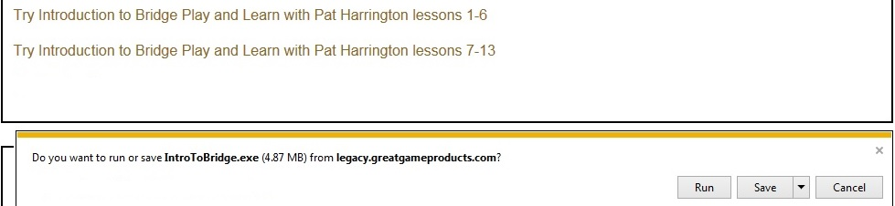

*NOTE- If using Chrome you can click on the setup file as shown below

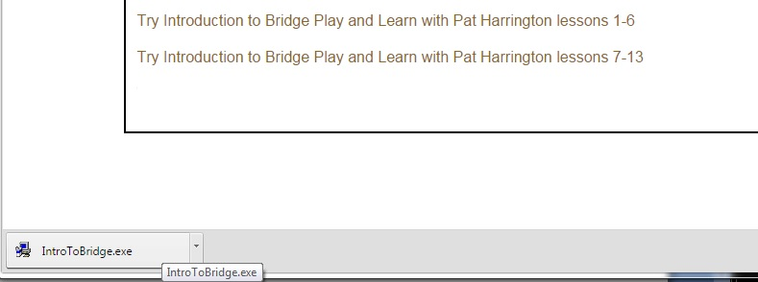

Once you click on the setup file your installation will start

Simply follow the prompts on the screen to complete the installation

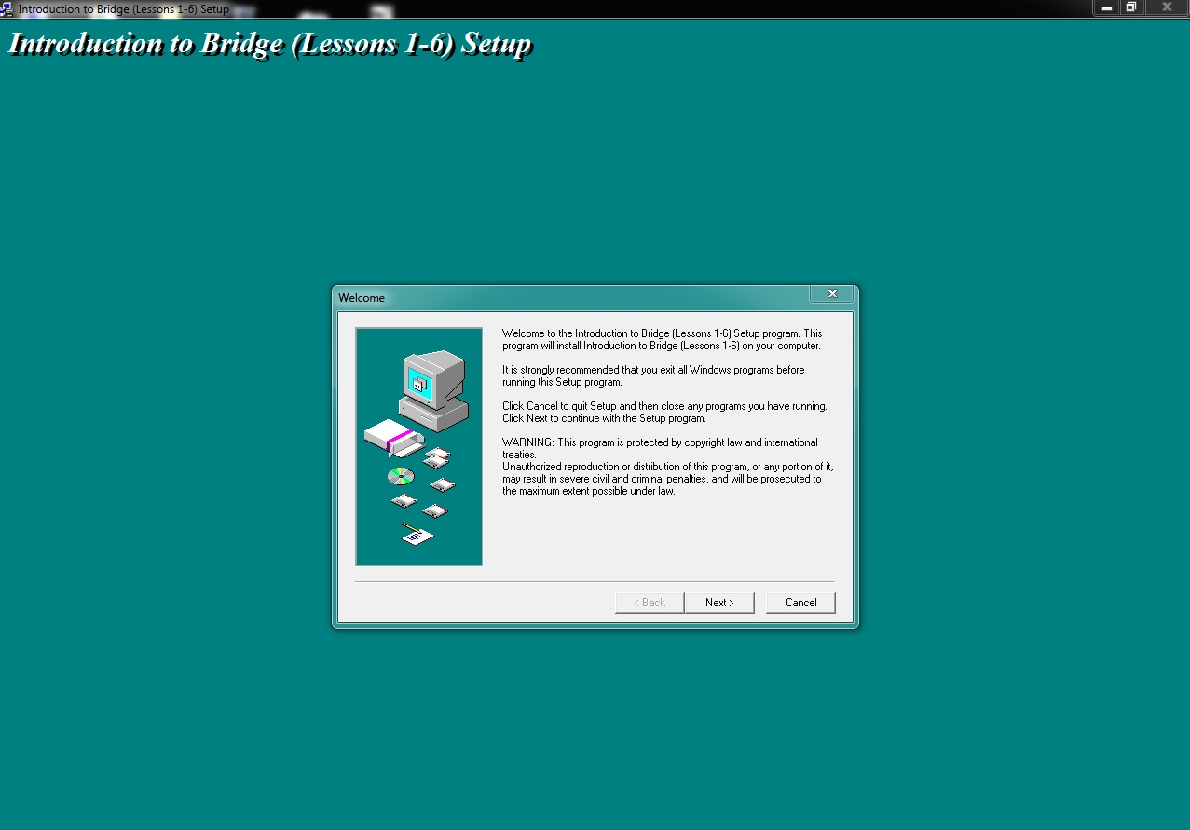

Once the installation is complete your will see an icon on your desktop

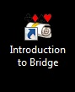

Double click on the “Introduction to Bridge” icon to open your Pat Harrington Lessons to see the following screen

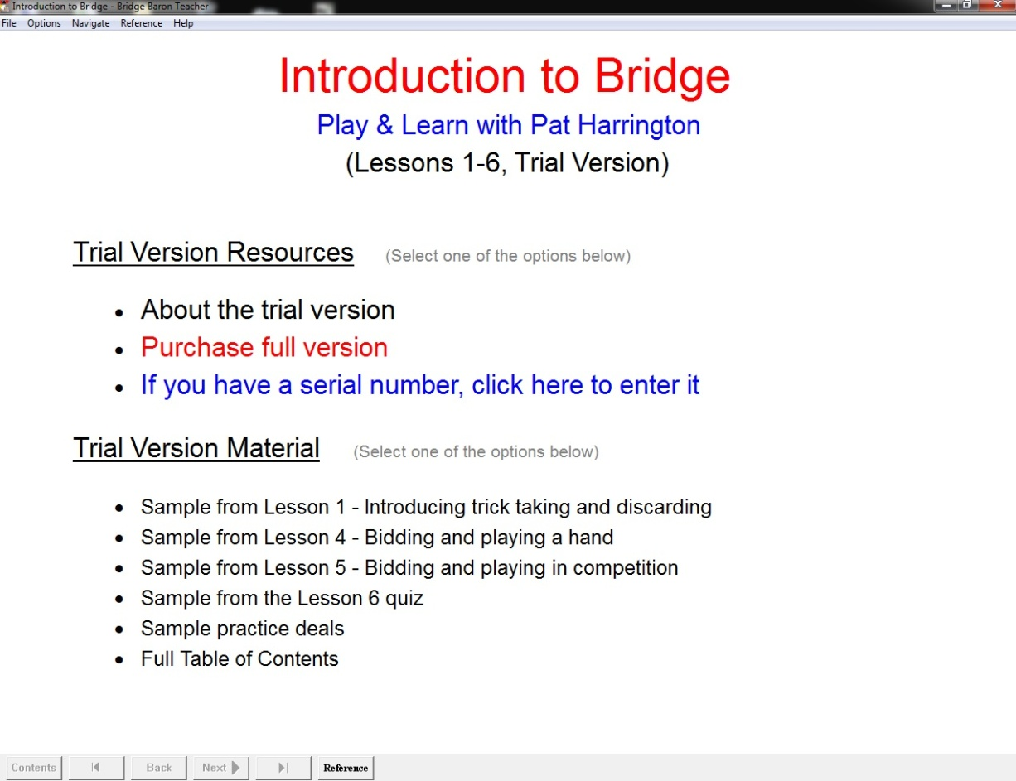

To activate your product simply click on “If you have a serial number, click here to enter it” and you will see the following window

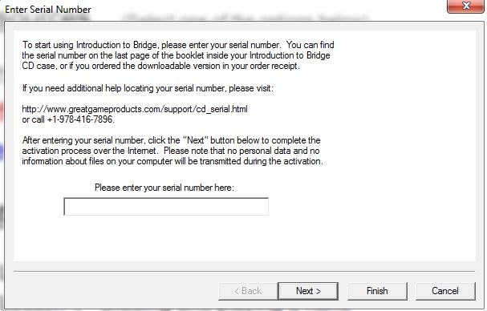
Once you enter your serial number and click on “Next” the program will communicate with our servers to activate your lessons.

Once the serial number is accepted the program will ask you to restart the program for the changes to take effect. When you open your lessons again you will see a list of contents and you can then continue with your lesson.

